Analysing Windows Firewall Logs- Submission Template

- Complete the following table using the Field Names section of the log file:
(3 points)
Answer:

Header Field | Details
Version | 1.5
Software | Microsoft window firewall
Time Format | Local

- The log file consists of entries for one port scanning attempt on the Windows machine [IP address: 10.0.2.4]. Answer the following questions and add necessary screenshot. [Note: It is mandatory to provide the screenshot]. (4 points)

[Hint: Identify a sequence of dropped packets which has the same packet size and the destination ports seems to have been scanned in a particular sequence. Remember you are looking for packets received by 10.0.2.4]

Answer:

Question | Answer
What is the timestamp of the first entry of the port scanning attempt? | The timestamp for the first entry of the port scanning attack is by 02:32:32 on 2022-12-27.
What is the timestamp of the last entry of the port scanning attempt? | The timestamp of the last entry of the port scanning attempt is by 02:32:33 on 2022-12-27
How many entries are there for the port scanning attempt? | The total entries is 10
What is the packet size for the port scanning attempt? | The packet size for the port scanning attempt is 44 bytes
Which ports (destination ports) were scanned during the port scanning attempt? | The ports scanned were 21, 80, 135, 139, 445
What is the Source IP address of the port scanning attempt? | The source IP address of the scanning attempt are 10.0.2.15

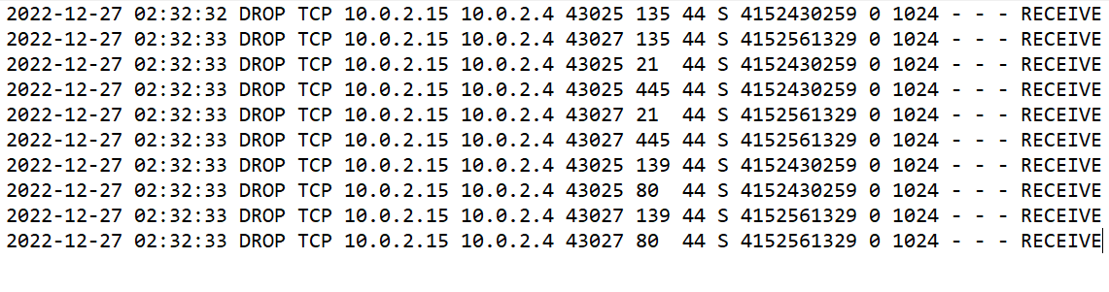
- Identify the request for a possible malicious single port connection on the Windows machine [IP address: 10.0.2.4]. Answer the following questions and add necessary screenshot. [Note: It is mandatory to provide the screenshot]. (4 points)

[Hint: Identify a sequence of dropped packets which has the same packet size and such that only one port has been scanned in all of these entries. Remember you are looking for packets received by 10.0.2.4]

Answer:

Question | Answer
What is the timestamp of the first entry of the single port connection attempt? | The timestamp of the first entry of the single port connection attempt is by 02:36:53 on 2022-12-27
What is the timestamp of the last entry of the single port connection attempt? | The timestamp of the first entry of the single port connection attempt is by 02:37:08 on 2022-12-27
How many entries are there for the single port connection attempt? | There are 8 entries
What is the packet size for the single port connection? | The packet size for the single port connection is 52
On which port (destination port) was the single port connection attempted? | The destination port for the single port connection attempted is 80
What is the Source IP address of the single port connection attempt? | The source IP address is 10.0.2.10

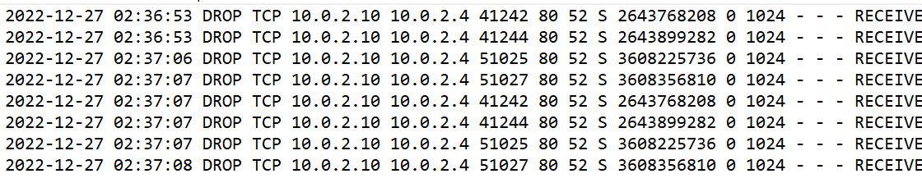

- Identify bad outgoing packets from the Windows machine [IP address: 10.0.2.4]. Answer the following questions and add necessary screenshot. [Note: It is mandatory to provide the screenshot]. (4 points)

[Hint: Identify a sequence of dropped outgoing packets from 10.0.2.4]

Answer:

Question | Answer
What is the timestamp of the first entry of the bad outgoing connection request? | The timestamp of the first entry of the bad outgoing connection request is by 02:39:50 on 2022-12-27
What is the timestamp of the last entry of the bad outgoing connection request? | The timestamp of the last entry of the bad outgoing connection request is by 02:39:50 on 2022-12-27
How many entries are there for the bad outgoing connection request? | There are 7 entries
On which port (destination port) was the bad outgoing connection request attempted? | on port 443
From which port (source port) was the bad outgoing connection request attempted? | From port 80
What is the destination IP address of the bad outgoing connection request? | The destination IP address is 10.0.2.10

